Student Name: Terence tang

Student id: 40091374

Course: FFAR 248

Section: BE

Title: Voices of Diversity

Cyber Love Hotel is an artist studio and space for exhibitions. it is located in the Montreal plateau area. The space welcomes artists from different backgrounds and orientations. It is also known for being LGBT-friendly. The space is multifunction as an exhibition space and a coworking spot for artists. Located on the unceded land of Kanien’kehá nation, Cyber Love Hotel acknowledges the complex history of Montreal while offering a creative space for digital and multimedia artists to engage and explore various subjects.

Cyber Love Hotel is the perfect space for creative exploration. Artists are welcome to explore in different media, including music, video art, video games and others. When there’s no exhibition, the space will be transformed into a coworking space where artists can communicate, collaborate and create. The studio also regularly hosts workshops and art jams. These events give artists a chance to explore new media, learn new skills, and share ideas in a collaborative environment.  The space is very diverse, where artists from marginalized communities, especially LGBT+, can freely express themselves. As someone that identify as part of the LGBTQ+ community and works on digital art, this space provides me with opportunities to exchange ideas with artists from diverse backgrounds.

               Different then most traditional art studios or exhibition spaces, Cyber Love Hotel focuses on digital and multimedia art. It set cyber love hotels apart from traditional art studios. There's no guideline for the exhibition being held at Cyber Love Hotel. It can be varying from a live performance to video game showcase. Here, it's not only the artwork that matters. The community also care about the story behind and the conversation between artists on subjects like identity, technology and community.

               Montreal has long been known for its support of artist-run spaces, like La Centrale, and Cyber Love Hotel is a new addition to these creative spaces. La Canale, one of Canada’s first artist-run centers, has been supporting feminist artists since 1973. (Mandate and history, la centrale) Partly similar to La Canale, Cyber Love Hotel creates a platform for artists from minor communities who find themselves hard to be noticed from other cultural institutions. These creative spaces together create a community in which different voices can be heard and valued. As more and more LGBT artists are recognized in both local and international contexts, with their works being showcased in different galleries and art fairs, creative spaces like Cyber Love Hotel become even more important in terms of shaping diverse narratives and making sure different voices can be heard.

               Cyber Love Hotel is a paradise for artists who are interested in multimedia art and seeking an inclusive creative space. It is not merely an art studio but also works as a space for cultural transformation. It allows artists to speak for themselves, get to understand each other, and potentially, collaborate and work together.

Resources

1. La Centrale. "Historique et Mandat." (2024) <https://www.lacentrale.org/en/a-propos/historique-et-mandat/>
2. Thaddeus-Johns, Josie. “What Does It Mean for Galleries to Support Queer Artists Today?” *Artsy*, June 8, 2022. https://www.artsy.net/article/artsy-editorial-galleries-support-queer-artists-today.

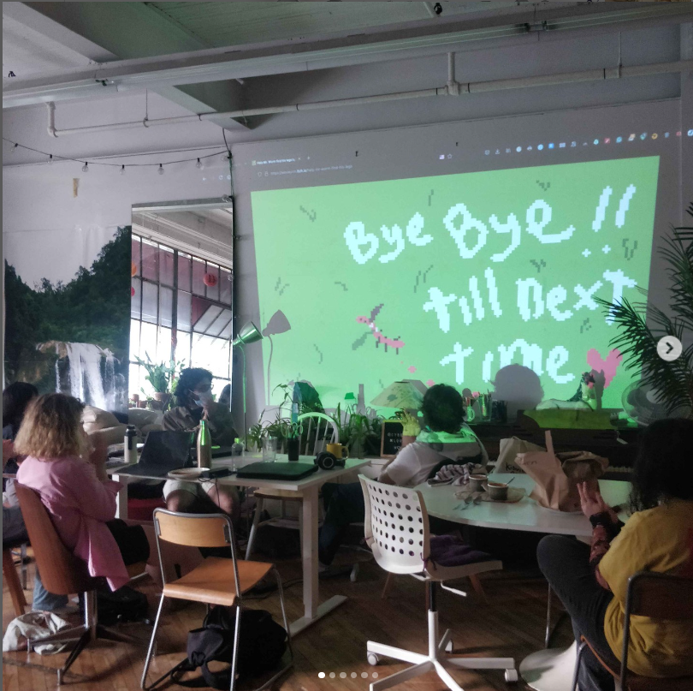

A photo from Cyber Love Hotel social media that showcase one of the workshop.